Test # 388
Instrument Name Consistometer #113 (1)
Instrument Type Consistometer
Test Start 13/07/01 18:30
Test Stop 14:31:58
Well ID #
Customer LUKOIL
Cement Class G
Additives 30%SF+0.35%THR-100+Dfmr
Cement Mfr DYKERHOFF
BHCT 158
BHST 158
Density 1960
Fluid Loss

Job Type PLUG
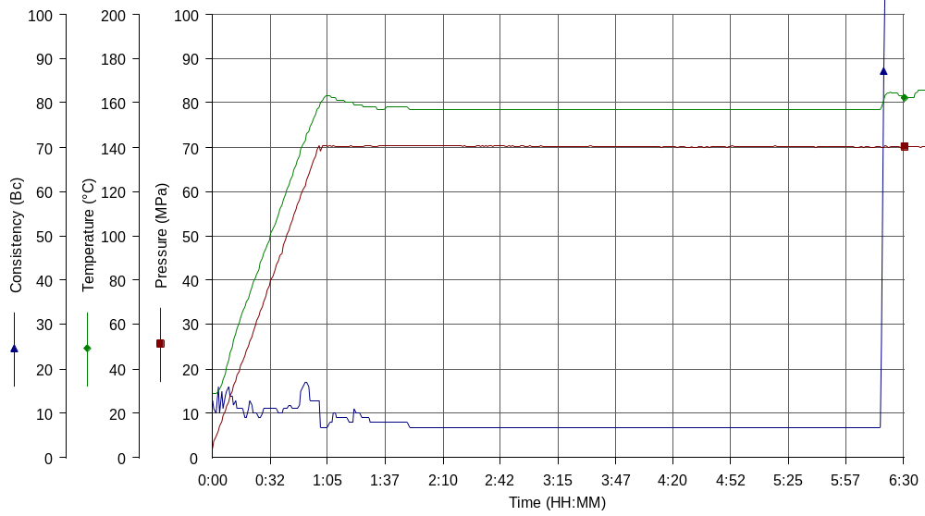
Comments MPa: 70(60min); T: 140C (50min), 158C(10min); tap water

